**Laser Rangefinder Range Equation**

1. **Noise Equivalent irradiance**

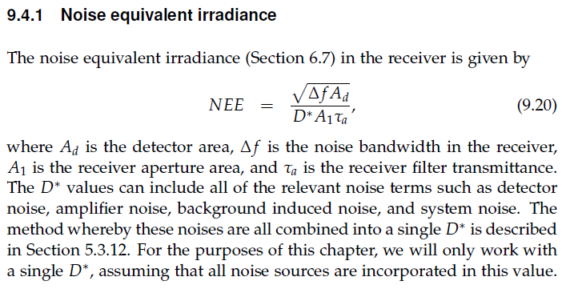 A1=AR

τa =

1. **Signal Irradiance**

Laser beam spot diameter and area at the target location.

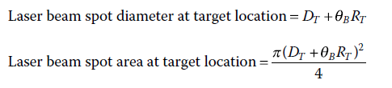

1. Power density at target location without considering the effect of atmospheric attenuation

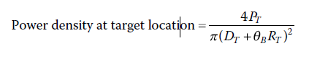

1. Power density at target location with considering the effect of atmospheric attenuation

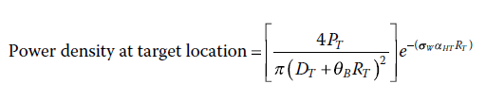

1. Power density at the target surface (target irradiance)

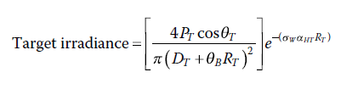

1. **Lambertian Target Reflectance**
2. Laser power density reflected from the target

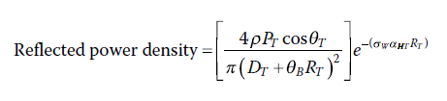

1. reflected power density per unit solid angle (target brightness)

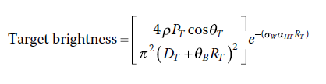

1. Power density available at the receiver location (Receiver Intensity)

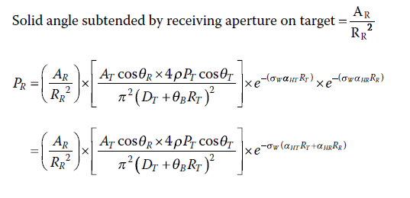

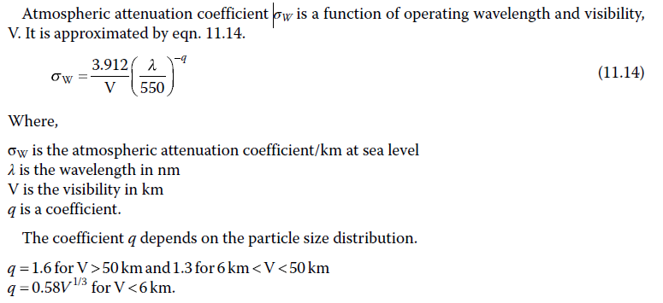

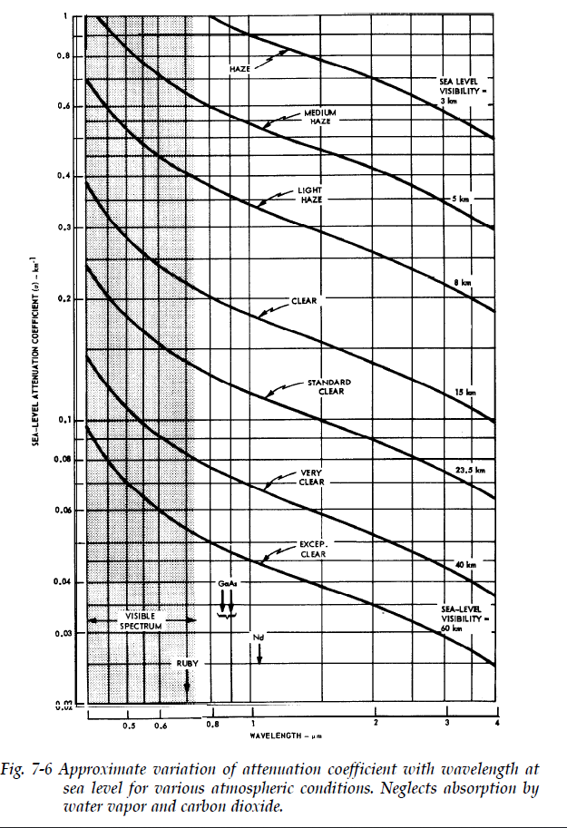

1. **Lambertian Target against the sky**

* 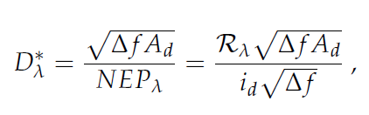Detector noise D*

*NEP = noise for particular device*

*Rλ = detector spectral responsivity [A/W]*

*id = detector noise current density [A/ $\sqrt{Hz}$]*

$$SNR=\frac{P_{R}}{NEE}= \frac{}{}$$

$$SNR= 4\frac{{A_{R}}^{2}A_{T}\cos{θ_{R}\cos{θ_{T}}ρP_{T}\sqrt{t_{p}}D^{*}e^{-2σ_{w}(∝_{HT}R_{T}+∝_{HR}R_{R})}}}{\sqrt{A_{d}K_{n}K_{f}} {π }^{2}{(D_{T}+ θ_{B}R_{T})}^{2}}$$

*The irradiance SNR can be written as:*

*No control Design Distance*

$$\frac{P_{R}}{NEE}=\left(\frac{4 A_{T}\cos{θ_{T}ρ}}{{π }^{2} \sqrt{K_{n}K_{f}} }\right) \left(\frac{{A_{R}}^{2}cosθ_{R} P_{T}\sqrt{t_{p}}D^{*} }{\sqrt{A_{d}}}\right)\left(\frac{e^{-2σ_{w}\left(∝_{HT}R_{T}+∝_{HR}R_{R}\right)}}{{\left(D_{T}+ θ_{B}R_{T}\right)}^{2}}\right)$$

*Transmitter:*

* *Wavelength λ= 1064nm*
* *Laser Energy per Pulse, Qp*
* *Laser pulse width tp*
* *Transmitted beam radius (half diameter)*
* *Transmitted beam half apex angle*

*Receiver:*

* *Detector area Ad*
* *Aperture diameter* *∅*
* *Detector noise D\**
* *Slant height H*
* *Slant angle*

*Target*

* *Target reflectivity ρ*
* *Target surface area AT*

**SAL Seeker Model:**

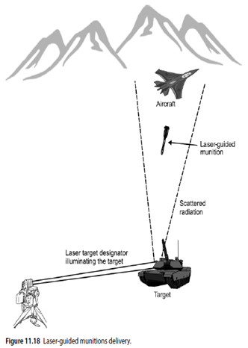

**Parameters:**

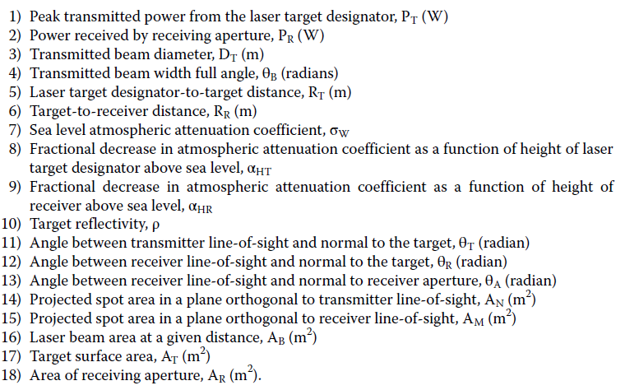

1. Receiver filter transmitter τa
2. Detector noise D*
3. Area of detector Ad
4. Pulse width tp
5. Time bandwidth product kf
6. Noise equivalent bandwidth kn

Atmospheric attenuation

